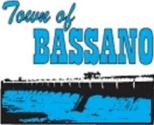

MINUTES OF THE RECREATION FUNDING COMMITTEE (RFC) – COMMITTEE MEETING HELD IN BASSANO COUNCIL CHAMBERS ON MAY 12, 2022.

COMMITTEE MEMBERS
CHAIR Arno Doerksen, County of Newell
VICE CHAIR Irvin Morey, Town of Bassano
MEMBERS Mike Wetzstein, Town of Bassano
Kelly Christman, County of Newell (Virtual)

STAFF Amanda Davis – Chief Administrative Officer

- CALL TO ORDER

The meeting was called to order by CHAIR DOERKSEN at 7:00 p.m.

- EXCUSED FROM MEETING

- None

- ADOPTION OF AGENDA

RFC01/2022 Moved by MEMBER MOREY that the May 12, 2022 agenda is approved a presented.
CARRIED
- ADOPTION OF MINUTES

4.1 Adoption of minutes from the regular meeting of October 13, 2021

RFC02/2022 Moved by MEMBER CHRISTMAN to approve the regular meeting minutes of October
13, 2021 as presented. CARRIED

- REPORTS

  - Administrative Report – Period Ending May 10, 2022

RFC03/2022 Moved by MEMBER WETZSETIN to accept the Administrative Report for the period
ending May 10, 2022 as presented and attached to and forming part of these minutes. CARRIED
UNFINISHED BUSINESS

None

- NEW BUSINESS

  - 2022 Recreation Grant Application Review

RFC04/2022 Moved by MEMBER WETZSTEIN that the recreation funding committee award 2022 grant applicants as follows:
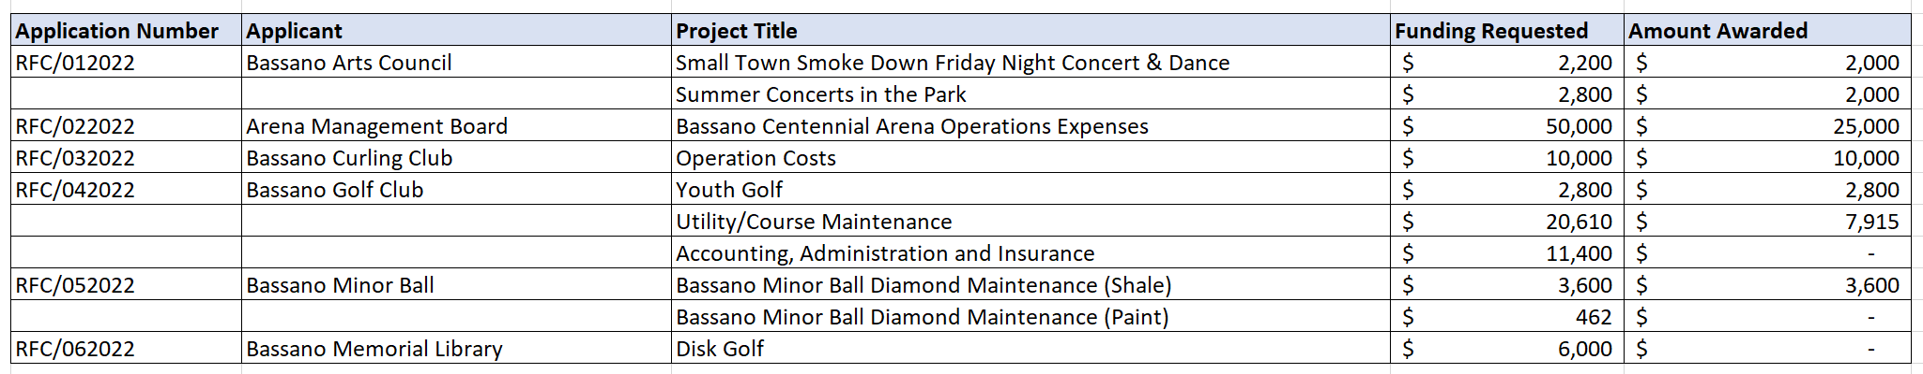
CARRIED

- OTHER
- None

- ADJOURNMENT

RFC05/2022 Moved by CHAIR DOERKSEN for adjournment at 8:15 p.m.
CARRIED

______________________ ___________________________
Chair Chief Administrative Officer

